LAB Instruction

What You Will Learn
- How to position elements outside of normal page flow
- How to float elements in a page

CSS Positioning and Floating
© 2014 Randy Connolly
Modified by Yasaman Amannejad, 2019
And again by PJ Perri, 2023
And yet again by Jim Davis 2026

 | Exercise 1. — Document Flow
1 |  | Open, examine, and test lab06-exercise01.html.
2 |  | Modify the following style inlab06-exercise01.css and test.  h1 span {  color: #8B0000;  font-size: 1.5em;  display: block;  }  This changes the <span> element in the main heading from an inline element to a block-level element.
3 |  | Add the following style and test.  li {  display: inline;  }  This changes the <li> elements from block-level to inline (they will thus show up on a single line now.
4 |  | Add the following style and test.  div img {  display: block;  }  This changes the images from inline to block-level (they now show up in a vertical column rather than a row.)

Positioning
Exercise 2. — Relative Positioning
 | 1 | Open, examine, and test lab06-exercise02.html.
 | 2 |  | Modify the following style inlab06-exercise02.css and test.  figure {  background-color: #EDEDDD;  border: 1pt solid #A8A8A8;  padding: 5px;  width: 150px;  }
 | 3 |  | Modify the following style and test.  figure {  background-color: #EDEDDD;  border: 1pt solid #A8A8A8;  padding: 5px;  width: 150px;  top: 150px;  left: 200px;  position: relative;  }  As you can see in Figure 5.1, the original space for the positioned <figure> element is preserved, as is the rest of the document’s flow. As a consequence, the repositioned element now overlaps other content.
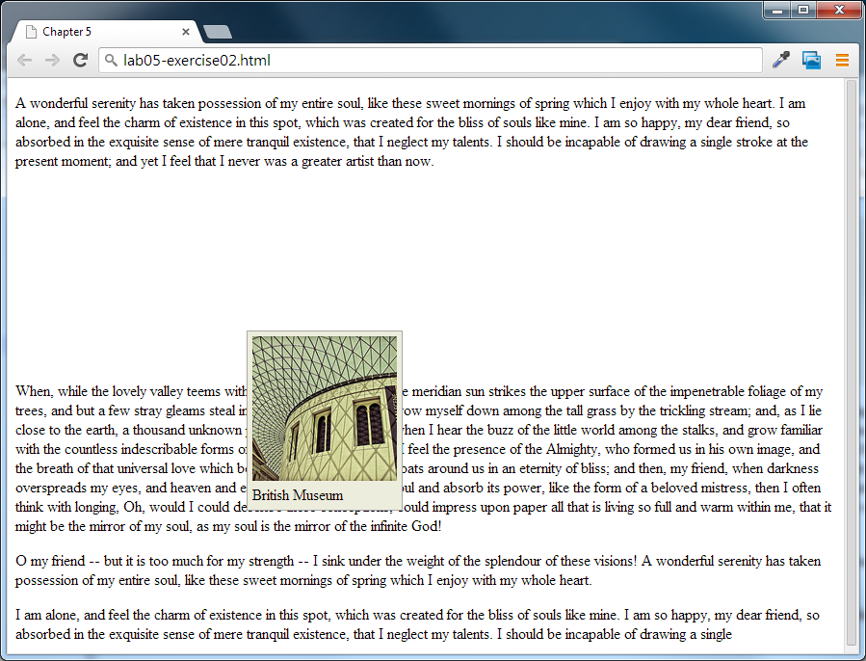
Figure 5.1 – Exercise 2 complete
 | Exercise 3. — Absolute Positioning
1 |  | Open, examine, and test lab06-exercise03.html.
2 |  | Modify the following style inlab06-exercise03.css and test.  figure {  background-color: #EDEDDD;  border: 1pt solid #A8A8A8;  padding: 5px;  width: 150px;  position: absolute;  }  With absolute positioning, space is not left for the moved element, as it is no longer in the normal flow.
3 |  | Modify the following style and test.  figcaption {  background-color: #EDEDDD;  padding: 5px;  top: 150px;  left: 200px;  position: absolute;  }  A moved element via absolute position is actually positioned relative to its nearest positioned ancestor container (that is, a block-level element whose position is fixed, relative, or absolute). In this example, the <figcaption> is absolutely positioned; it is moved 150 px down and the left edge is set to 200 px effectively moving the caption down and to the right of its nearest positioned ancestor, which is its parent (the <figure> element).

 |  |  | Exercise 4. — Stacking Using Z-Index
 |  | 1 |  | Open, examine, and test lab06-exercise04.html.
 |  | 2 |  | Modify the following style and test.  figure {  background-color: #EDEDDD;  border: 1pt solid #A8A8A8;  padding: 5px;  width: 150px;  top: 150px;  left: 200px;  position: absolute;  }  figcaption {  font-size: 1.25em;  background-color: yellow;  padding: 5px;  top: 90px;  left: 140px;  position: absolute;  }  Notice that the caption now overlaps both the underlying paragraph text and the figure image
 |  | 3 |  | Modify the following styles (some CSS omitted here for clarity) and test  figure {  position: absolute;  z-index: 5;  }  figcaption {  position: absolute;  z-index: 1;  }  Note that this did not move the <figure> on top of the <figcaption> as one might expect. This is due to the nesting of the caption within the figure
4 |  |  |  |  | Modify the following styles and test  figure {  position: absolute;  z-index: 1;  }  figcaption {  position: absolute;  z-index: -1;  }  This moves the image in front ot the caption. The <figure> zindex could be any value equal to or above 0 as long as the <figcaption> is below 0.
5 | Modify the following styles and test.  figure {  position: absolute;  z-index: -1;  }  figcaption {  position: absolute;  z-index: 1;  }  If the <figure> zindex is given a value less than 0, then any of its positioned descendants change as well. Thus both the <figure> and <figcaption> move behind the body text.

Floating
 | Exercise 5. — Floating Elements
1 | Open, examine, and test lab06-exercise05.html.
2 | Modify the following styles and test.  figure {  border: 1pt solid #A8A8A8;  background-color: #EDEDDD;  padding: 5px;  margin: 10px;  float: left;  }  Notice that a floated block-level element must also have a width specified.
3 | Modify the following styles and test.  figure {  border: 1pt solid #A8A8A8;  background-color: #EDEDDD;  padding: 5px;  margin: 10px;  width: 150px;  float: right;  }

 | Exercise 6. — Floating in a Container block Element
1 | Open, examine, and test lab06-exercise06.html.  Notice the empty margin space on the left.
2 | Modify the following styles and test.  figure {  border: 1pt solid #262626;  background-color: #c1c1c1;  padding: 5px;  width: 150px;  margin: 10px;  float: left;  }  Notice that a floated item moves to the left or right of its container. In this case the container for the floated <figure> is the <article> element.

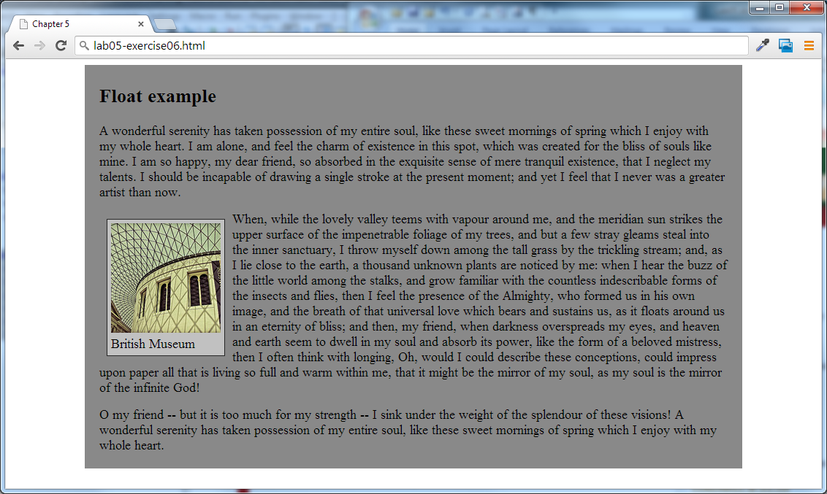
Figure 5.2 – Exercise 6 complete

 | Exercise 7. — Using Positioning
1 | Open, examine, and test lab06-exercise07.html.  In this exercise, we are going to position the caption on top of the image.
2 | Modify the following style and test.  figcaption {  width: 100px;  background-color: black;  color: white;  opacity: 0.6;  width: 140px;  height: 20px;  padding: 5px;  position: absolute;  top: 130px;  left: 10px;  }  Since absolute positioning is positioning in relation to the closest positioned ancestor, we will also need to position the <figure>.
3 | Modify the following style and test.  figure {  border: 1pt solid #262626;  background-color: #c1c1c1;  padding: 10px;  width: 200px;  margin: 10px;  position: relative;  }  Notice that we are not moving the figure. Instead by setting its position to relative, we are creating a positioning context for the absolute positioning in the previous step.

4 | Add the following markup and test.  <figure>  <img src="images/828.jpg" alt="" />  <figcaption>British Museum</figcaption>  <img src="images/new-banner.png" alt="" class="overlayed"/>  </figure>
5 | Add the following style and test.  .overlayed {  position: absolute;  top: 10px;  left: 10px;  }  If you have problems getting the overlay, check the stylesheet declaration to make sure it links to: lab06-exercise07.css
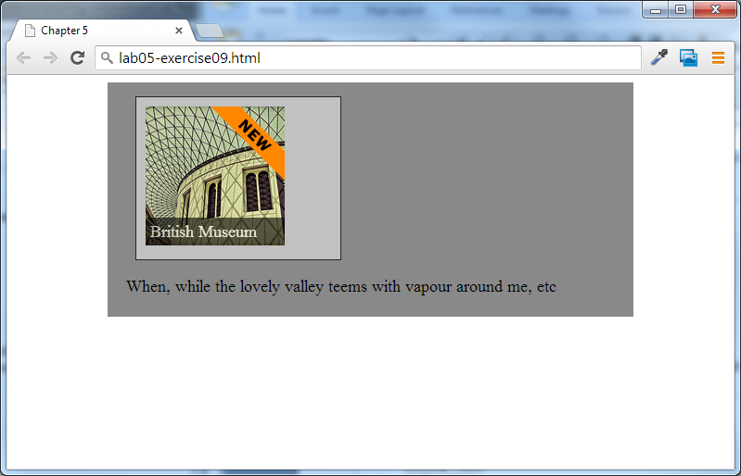
Figure 5.3 – Exercise7 complete

Summary
Create a docx summary describing what you’ve demonstrated through this lab. Include:
  - Block vs inline
  - Positioning: all kinds
  - Z-index
  - Floating: left, right & within a ‘container’

